* + 1. **Have you have done any programming before  
       and if so, in what language and what did you build?**

Yes, I studied Html and Css last year in a creative multimedia course and built a computer repair and component shop website. I also learned small amounts of javascript and incorporated it into my website to allow for scrolling images. Similarly I learned some actionscript to allow me to create interactive flash advertisements with clickable links.

* + 1. **Why are you doing computer science, what is your interest in programming**

I enjoy bringing my own ideas into creation and believe coding is the best way to do this. I’m also interested because I know that this is a rapidly expanding industry with great career opportunities

* + 1. **What is your favourite Website, App and software – Why?**

My favourite website is Google; app is Shazam and software is Photoshop

* + 1. **What piece of software, app or website do you wish you had created or would like to create?**

I wish I had created and would like to create a website which affects millions of people’s lives every day such as the social media websites, “Facebook” and “Twitter” and the search engine, “Google”.

* + 1. **Your hobbies and interests**

I enjoy socialising, reading, playing guitar, playing games

* + 1. **An interesting fact about you**

I once repaired my laptop by cooking it in the oven



There are six eggs in the basket. Six people each take one of the eggs. How can it be that one egg is left in the basket?

|  |  |  |
| --- | --- | --- |
| Person | Eggs Taken | Can take basket |
| Number 1 | 1 | No, 5 people left |
| Number 2 | 2 | No, 4 people left |
| Number 3 | 3 | No, 3 people left |
| Number 4 | 4 | No, 2 people left |
| Number 5 | 5 | No, 1 person left |
| Number 6 | 6 | Yes, no one left |

|  |
| --- |
|  |
| You are trying to get to a place called Village A. However, on your travel, you come to a fork in the road which leads to two identical villages, Village A and Village B. From a friend, you know already know village A will tell the truth at all times, and village B will always lie. Trying to decide, a man walks past you in the road. You are only allowed to ask him one question about trying to get to you destination, without knowing whether he is from village a or b. What do you ask? |
|  |
| "Which of these two paths will take me to the village where you live?" |

|  |  |
| --- | --- |
| Lieing | Truthful |
| Points at Village A as he can’t tell truth | Points at village A as telling truth |

Week 3

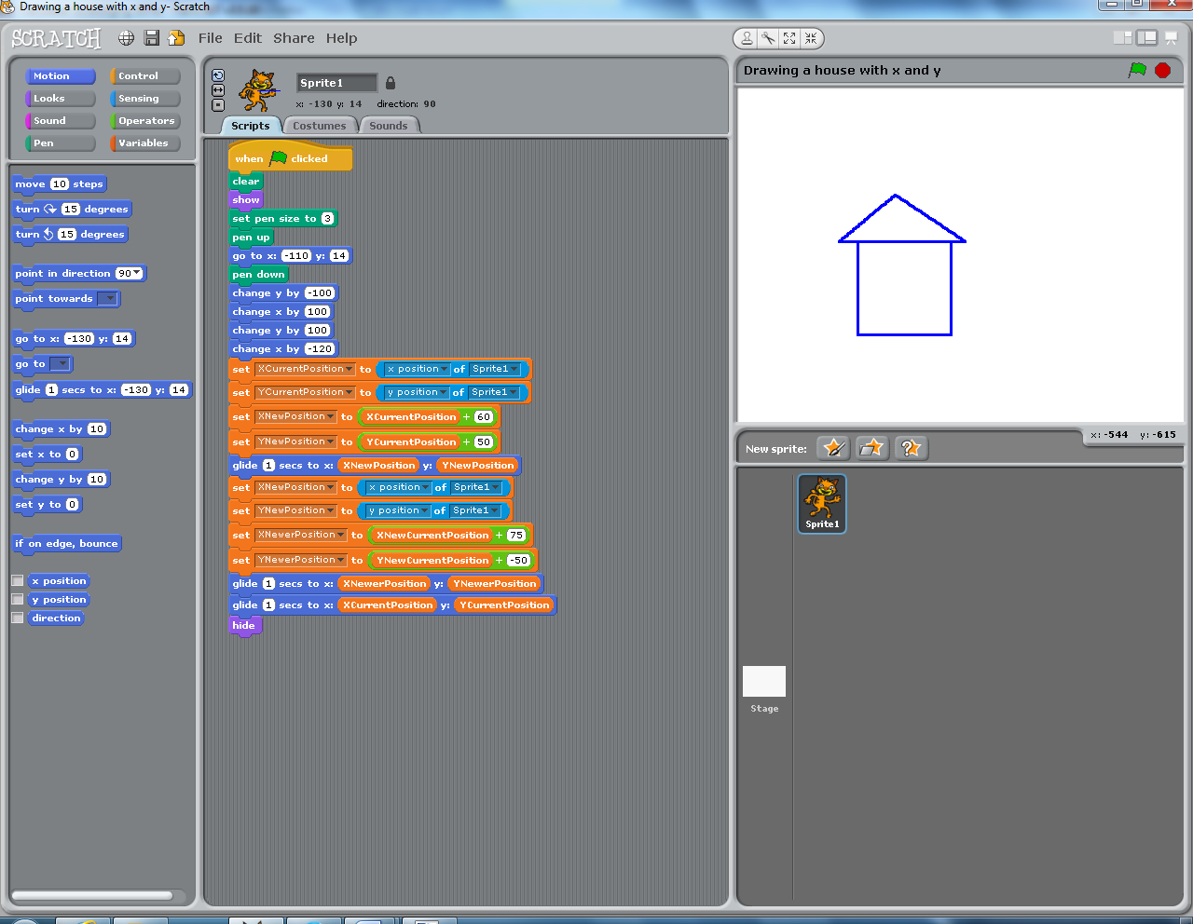

House Constructed using pen and co ordinates in Scratch

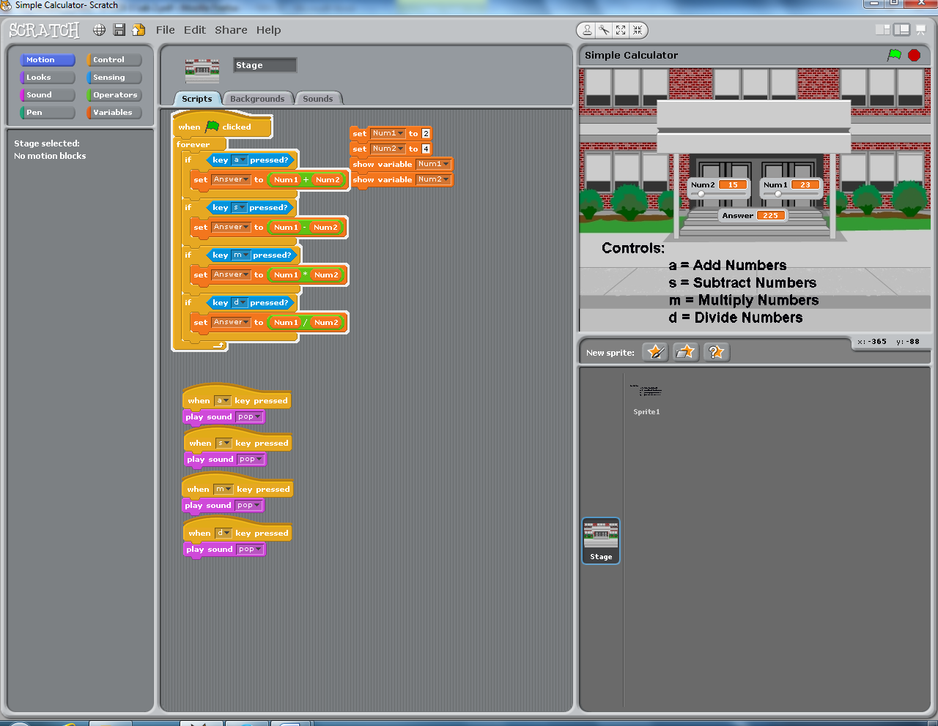

Calculator made in Scratch

Week 4

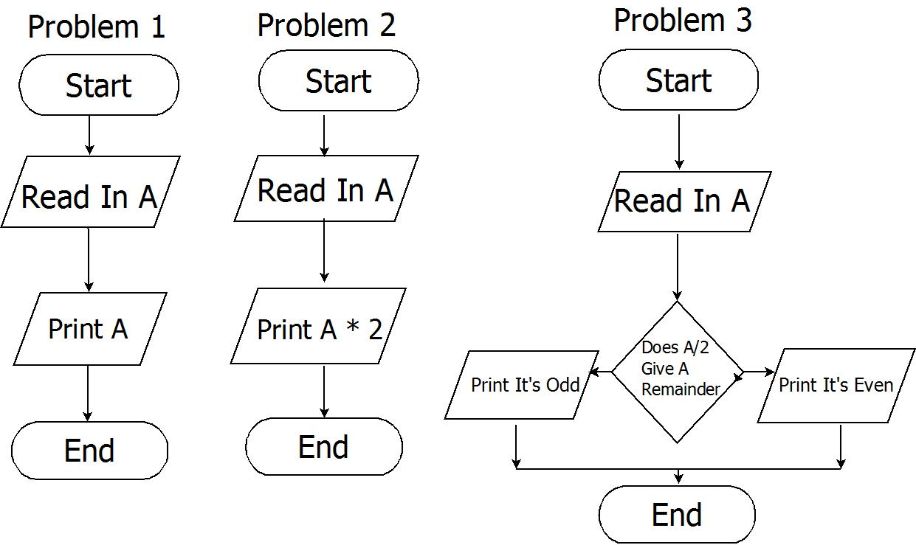

Flowchart 1 -3

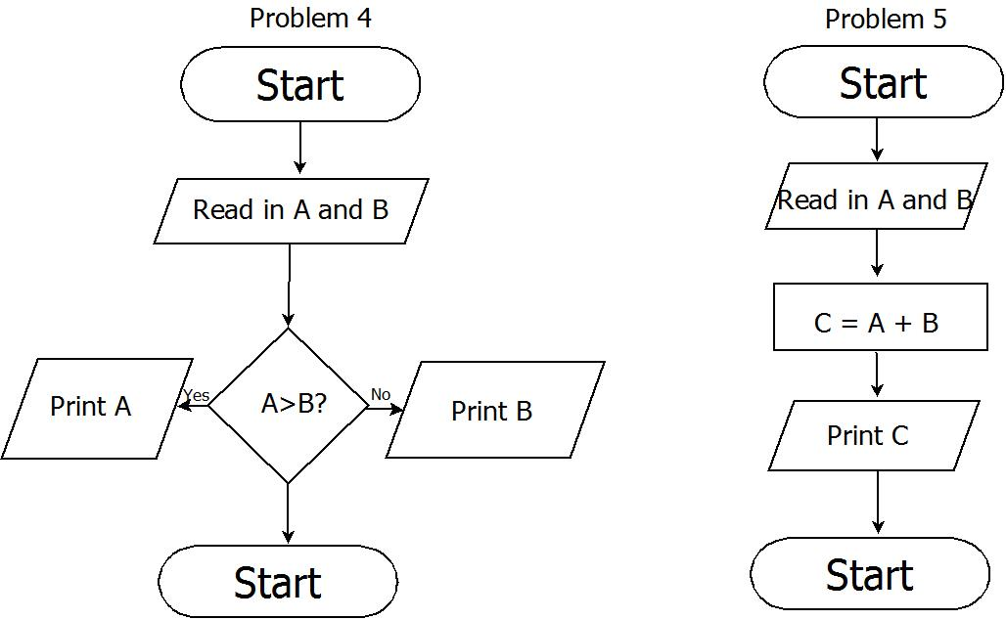

Flowchart 4-5



Flowchart 6

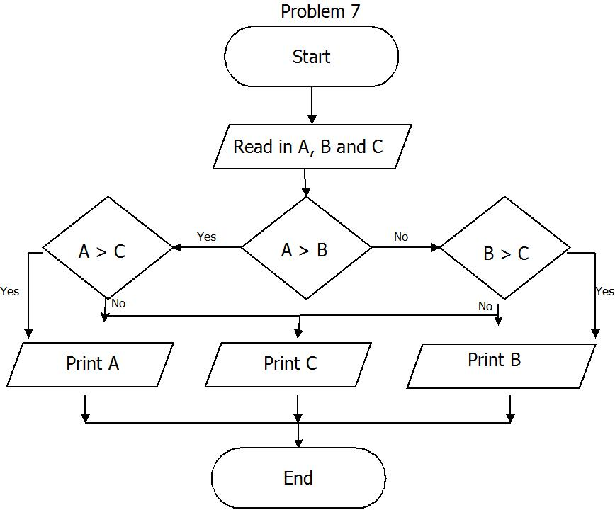

Flowchart 7

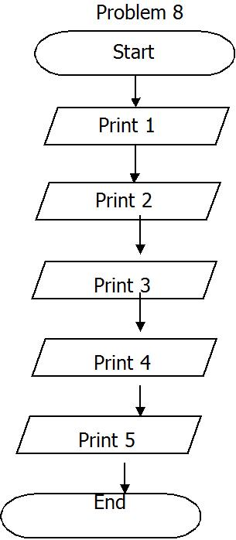

Flowchart 8

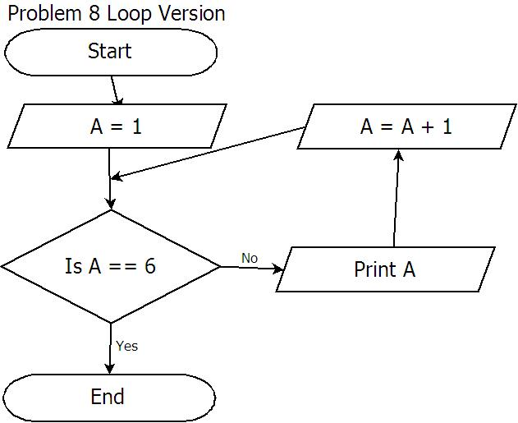

Flowchart 8 Loop Version

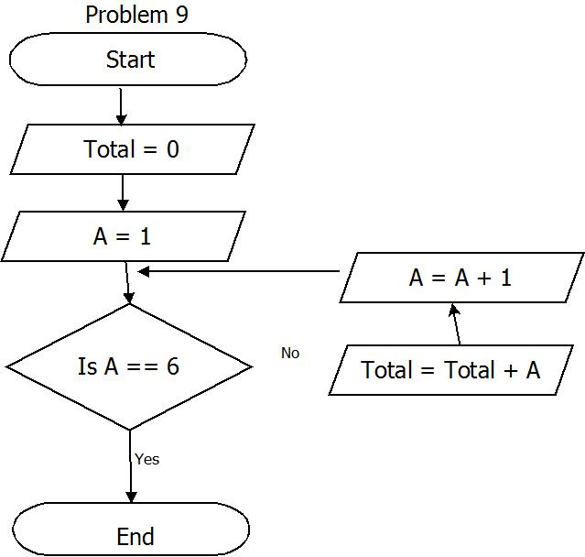

Flowchart 9

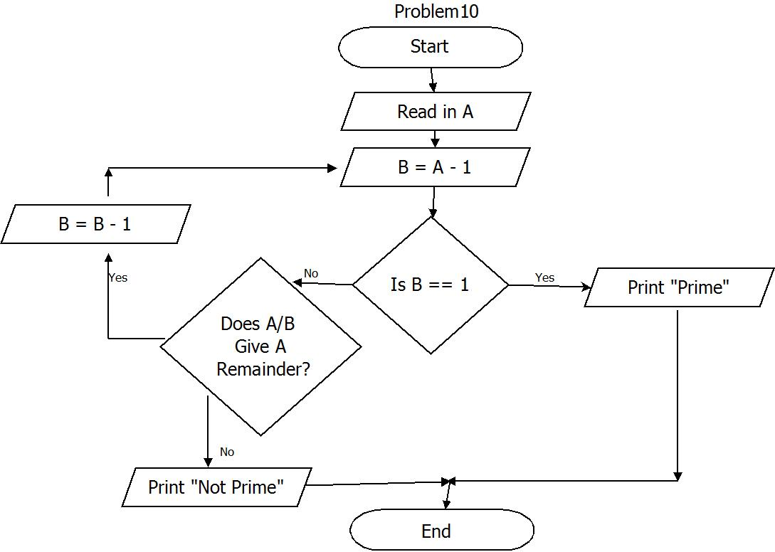

Flowchart 10

Week 4

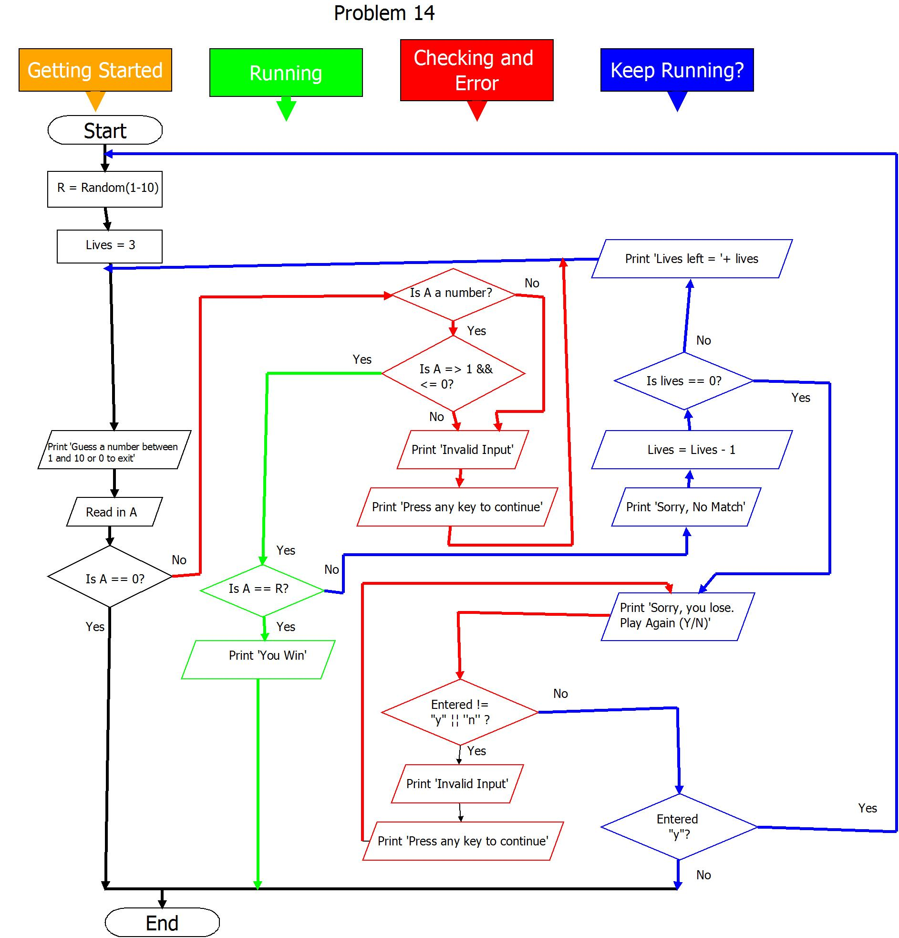

Flowchart 14

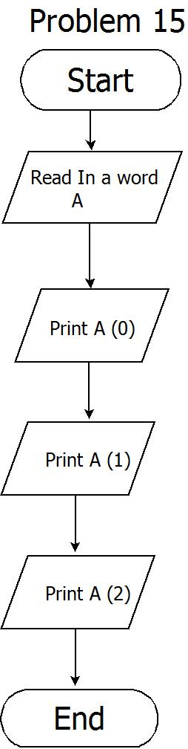

Flowchart 15

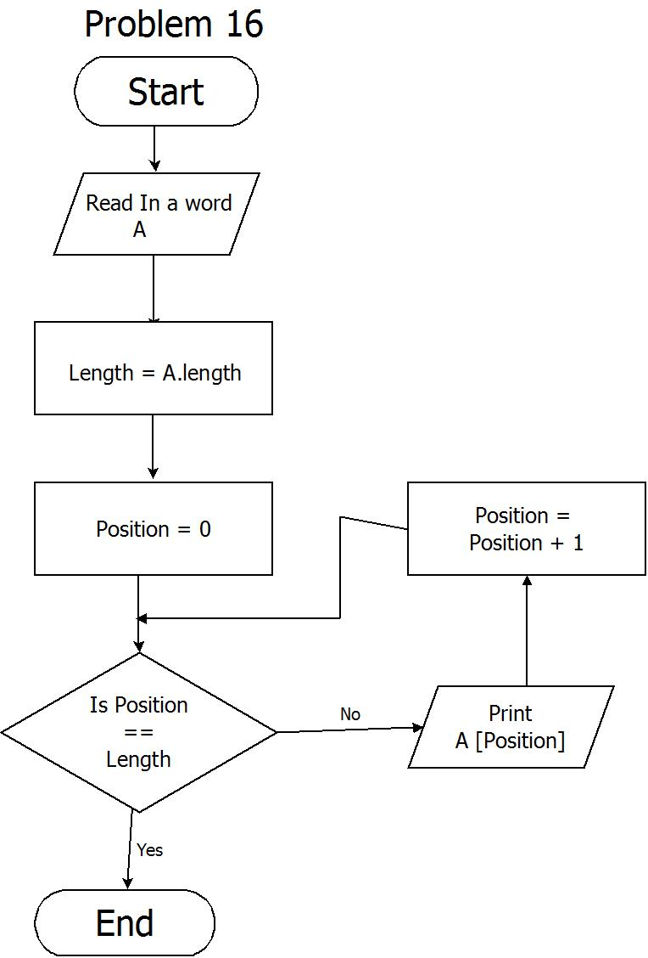

Flowchart 16

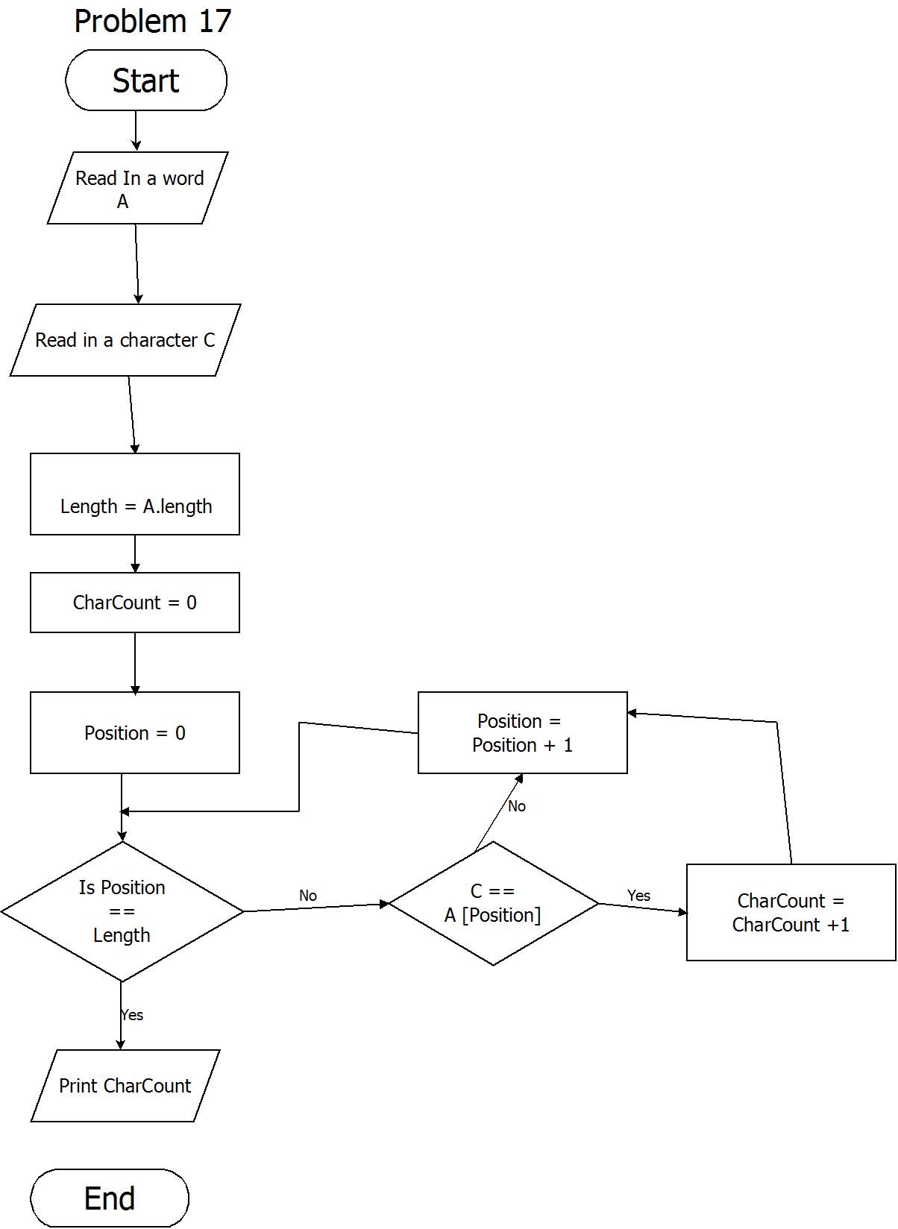

Flowchart 17

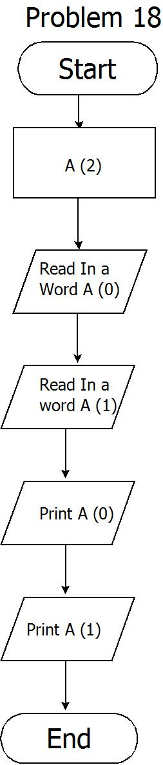

Flowchart 18

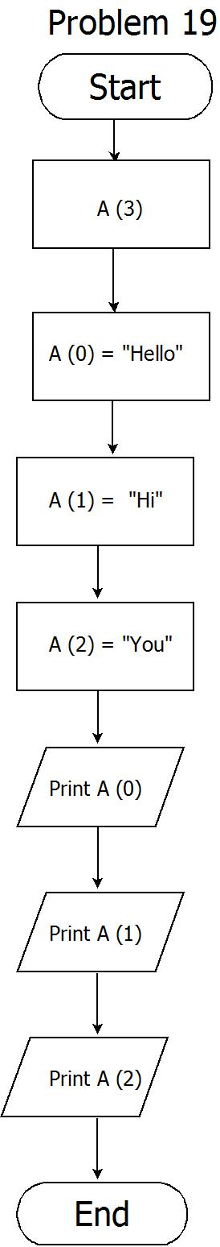

Flowchart 19

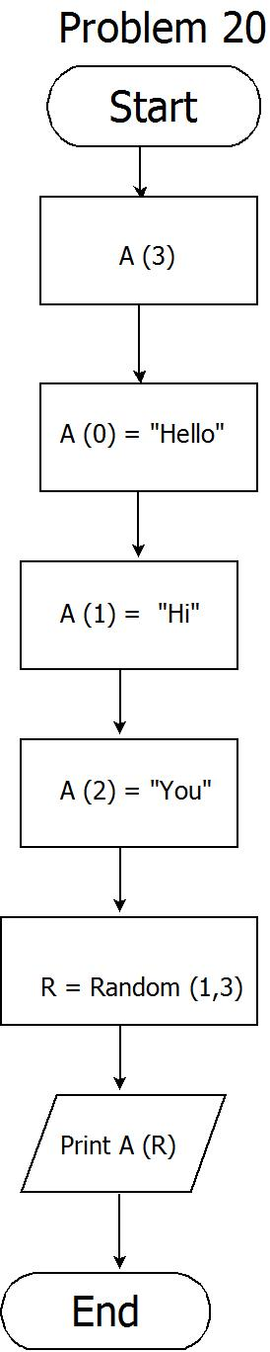

Flowchart 20

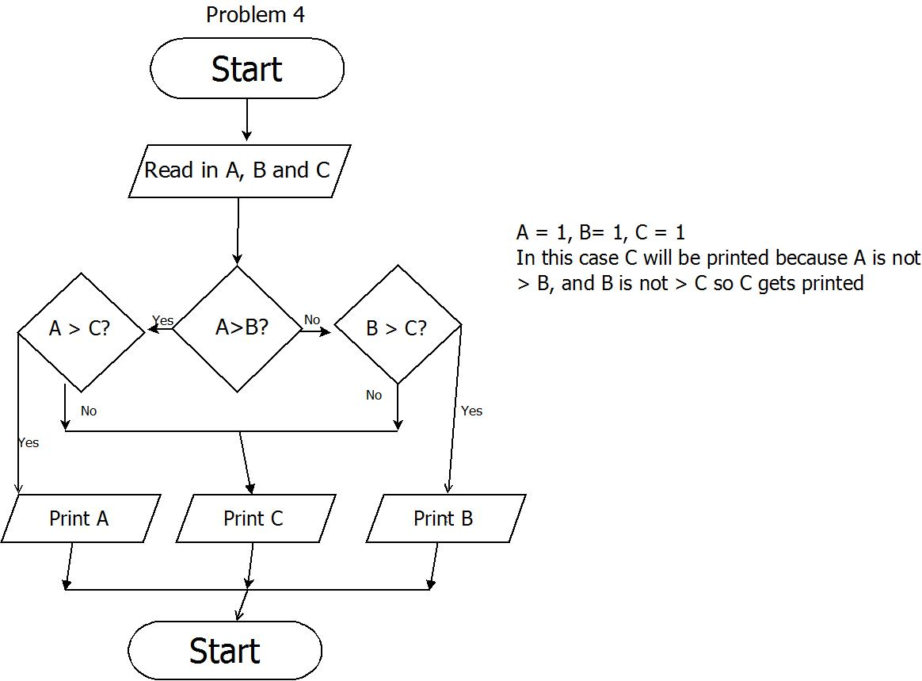

Tutorial 3 Exercise 1



Tutorial 3 Exercise 2

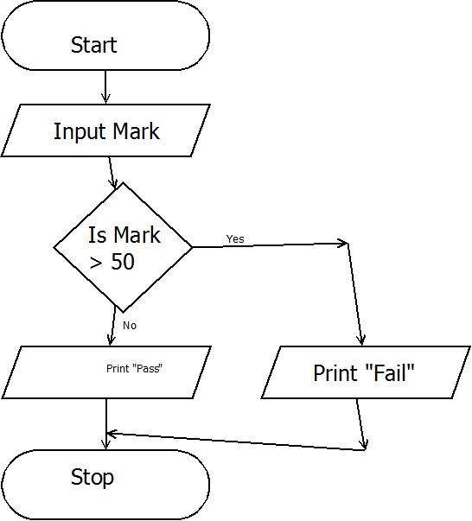

Tutorial 3 Exercise 3

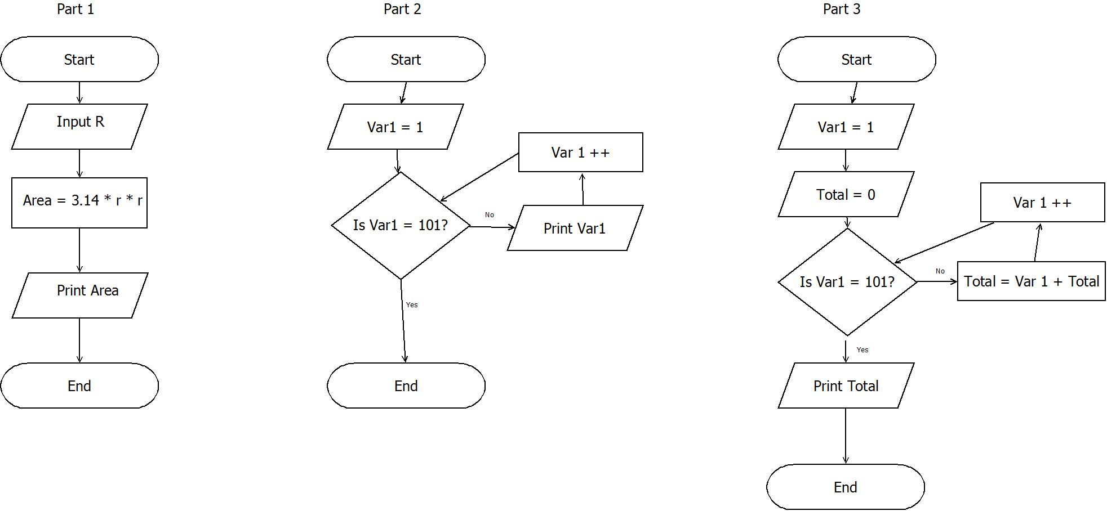

Tutorial 3 Exercise 4 Parts 1 -3